
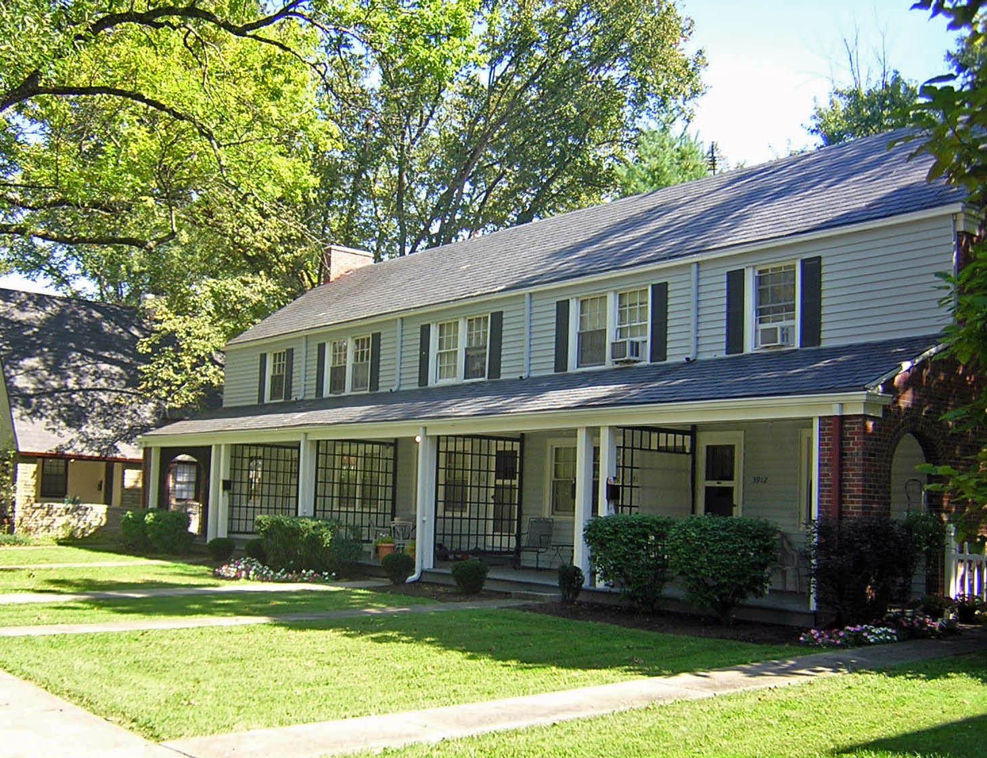

3918 Beech Street

Unit includes…

* Two-bedroom townhouse

* Eat-in kitchen with pantry

* Finished basement with washer and dryer hook-ups

* Fenced backyard with private patio

* Covered front porch

* Detached garage

* Cable ready

* Pet-friendly environment, call for details.

$725 per month

For Inquiries or to make an appointment for a showing for this townhouse, call
513-861-2861 or 513-607-2640



For Inquiries or to make an appointment for a showing for this townhouse, call
513-861-2861 or 513-617-5747

